An operational amplifier is an integrated circuit that can amplify weak electric signals. An operational amplifier has two input pins and one output pin. Its basic role is to amplify and output the voltage difference between the two input pins.

In the most basic circuit, op-amps are used as voltage amplifiers, which can be broadly divided into noninverting and inverting amplifiers. Voltage followers (also simply called buffers) are a type of commonly used noninverting amplifiers. Op-amps are also used as differential amplifiers, integrator circuits, etc.

The centre frequency of a band-pass filter is always equal to the
bandwidth
–3 dB frequency
bandwidth divided by Q
geometric average of the critical frequencies

The formula 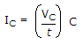shows that for a given capacitor, if the voltage changes at a constant rate with respect to time, the current will
increase
decrease
be constant
decrease logarithmically

A zero-level detector is a
comparator with a sine-wave output
comparator with a trip point referenced to zero
peak detector
limiter

A digital-to-analog converter is an application of the
scaling adder
voltage-to-current converter
noninverting amplifier
adjustable bandwidth circuit

DAC has the same circuit as that of the scaling adder where each input is multiplied by the ratio of the feedback resistance to input resistance which determines its value, for example, bit 0 has Rin = 8R, bit 1 has Rin = 4R and Rf = feedback resistance = R.
Then, Vo = Rf(Vin1/Rin1 +Vin2/Rin2),
Vo = R(Vin1/8R+Vin2/4R) = (Vin1)/8 + (Vin2)/4 representing a digital signal 10 as an analog signal.

If the value of resistor R_{f} in an averaging amplifier circuit is equal to the value of one input resistor divided by the number of inputs, the output will be equal to
the average of the individual inputs
the inverted sum of the individual inputs
the sum of the individual inputs
the inverted average of the individual inputs

For an averaging amplifier, Rin is equal for all inputs and the formula for Vo is,
Vo = (-Rf)(Sum of Inputs/Rin) but since Rf = Rin/(# of inputs) then,
Vo = -(Rin/(# of inputs))((Sum of Inputs)/Rin), Rin would cancel and you would have,
Vo = -((Sum of Inputs)/(# of inputs)), which is basically an inverted(negative) average of the individual inputs.

If the input to a comparator is a sine wave, the output is a
ramp voltage
sine wave
rectangular wave
sawtooth wave

Def:
A comparator compares two input voltages and outputs a binary signal indicating which is larger.
If the non-inverting (+) input is greater than the inverting (-) input, the output goes high.
If the inverting input is greater than the non-inverting, the output goes low.
Used for:
comparison between a voltage and a stable reference.
Applications:
threshold detectors/discriminators, zero-crossing detectors, and oscillators.

In an inverting comparator (or negative voltage comparator), the input signal is applied to the inverting terminal and the reference voltage is at the non-inverting terminal. This creates a positive voltage output if the input voltage is less than the reference voltage.
In a non-inverting comparator, the input signal is applied to the non-inverting terminal and the reference voltage is at the inverting terminal. This creates a positive voltage output if the input voltage is greater than the reference voltage.
A simple comparator can be achieved using an op amp without negative feedback.

A basic series regulator has
an error detector
a load
a reference voltage
both an error detector and a reference voltage

A basic series regulator is composed of a Zener diode for voltage reference and a BJT which serves as the error detector. It detects whether it need to give less or more current to the load via the reference of zener diode and a feedback loop.

Since series regulator has error detector that means it compare between input signal and reference signal (voltage). So, series regulator has both.

A Zener diode is a special type of diode designed to reliably allow current to flow "backwards" (inverted polarity) when a certain set reverse voltage, known as the Zener voltage, is reached.

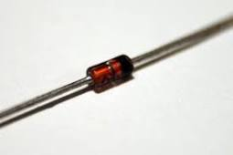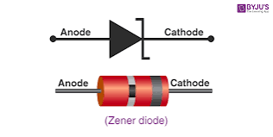

Zener diode applications
Zener diodes are used for voltage regulation, as reference elements, surge suppressors, and in switching applications and clipper circuits.
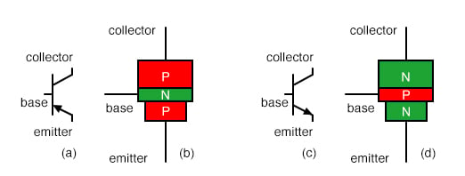

A bipolar junction transistor is a three-terminal semiconductor device that consists of two p-n junctions which are able to amplify or magnify a signal. It is a current controlled device. The three terminals of the BJT are the base, the collector, and the emitter.

The basic function of a BJT is typically to function as a switch or to amplify, filter, and rectify power.

What is difference between FET and BJT?
A type of transistor which uses two types of charge carries viz. electrons and holes for conduction is known as bipolar junction transistor (BJT). A type of transistor in which electric field is used to control the flow of current in a semiconductor is known as field effect transistor (FET).

The error detector compares the feedback signal (representing actual position) with the command signal (representing desired position). Any discrepancy results in an error signal that represents the correction necessary to bring the controlled device to its desired position.

Where is error detector used?
In control systems, error detectors are used to sense and measure any error, which may occur due to the difference between the actual output and the desired output.

What is a feedback loop?

A feedback loop is the part of a system in which some portion (or all) of the system's output is used as input for future operations.

A Linear circuit is one whose parameters are constant with time and they do not change with voltage or current and circuit obeys Ohm's Law.
A Non Linear circuit is that circuit whose parameters change with voltage or current and circuit does not obey Ohm's Law. They obey the properties of ohm's law.

A comparator is an example of a(n)
active filter
current source
linear circuit
nonlinear circuit

In an averaging amplifier, the input resistances are
equal to the feedback resistance
less than the feedback resistance
greater than the feedback resistance
unequal

in which the output voltage is equal to the average of all the input voltages.

What is integrator and differentiator?
The Integrator is a circuit that converts or 'integrates' a square wave input signal into triangular waveform output.

What Is Differentiator? The Differentiator circuit converts or 'differentiates' a square wave input signal into high frequency spikes at its output.

A triangular-wave oscillator can consist of an op-amp comparator, followed by a(n)
differentiator
amplifier
integrator
multivibrator

